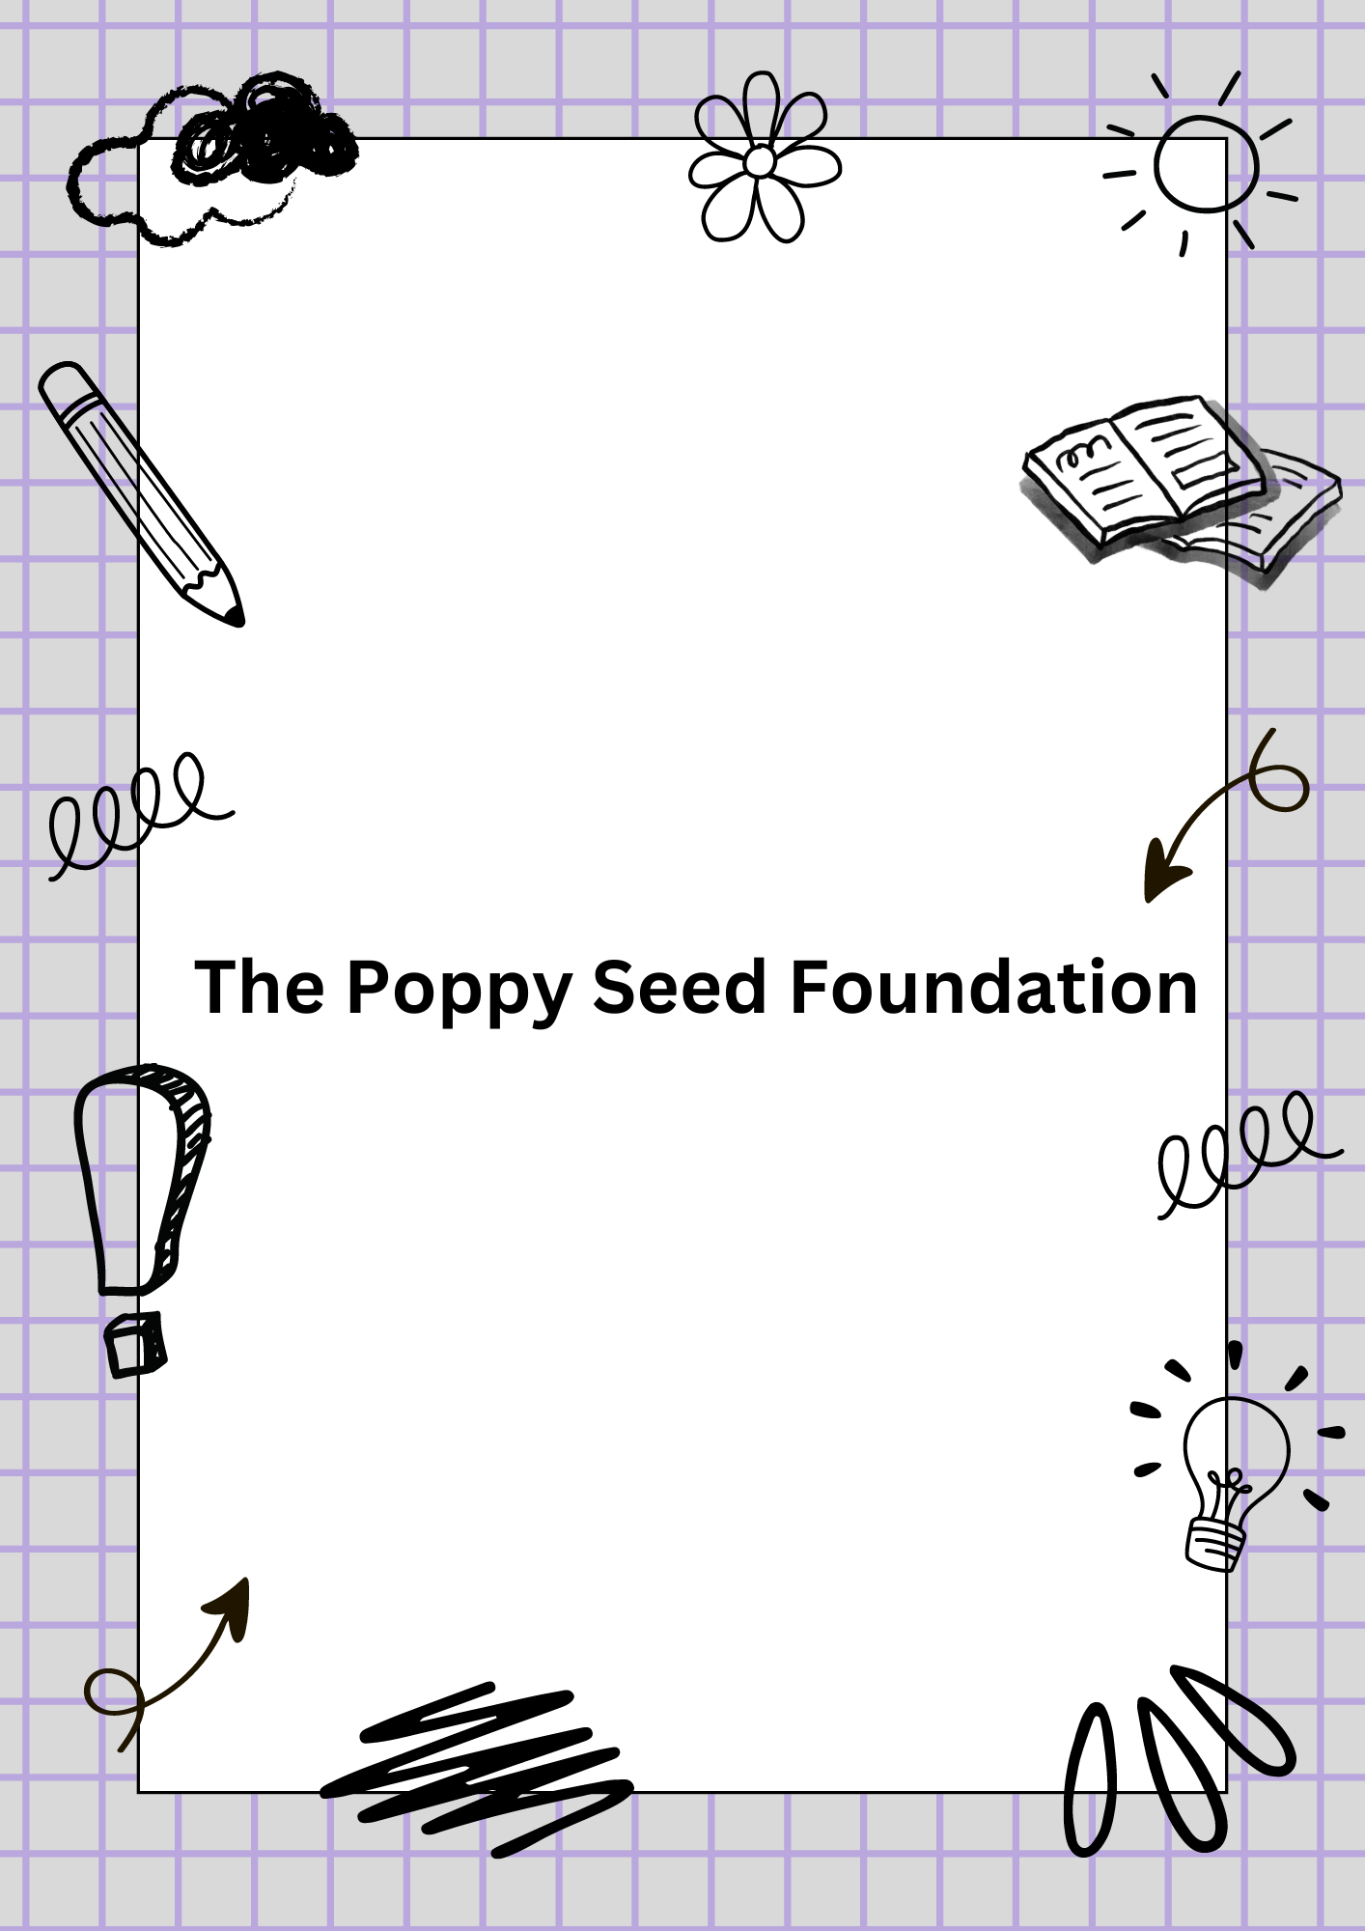

Table of Contents
Purpose of this Document: 3

Purpose of this Document:
This document outlines the structure, roles, and assigned projects for The Poppy Seed Foundation, guiding the successful execution of tasks leading up to the foundation's formal launch in February next year. The document also details how responsibilities are distributed among team members to ensure all objectives are met on time.

Organizational Structure:

NAME | ROLE | RESPONSIBILITY
Terry-Ann | CEO and Founder | Overseeing the entire foundation while setting the mission, vision, and managing the overall strategy.
Jamie-Lee | Chief Digital Officer and Co-Founder | Managing the foundations digital presence, including the website, domain setup, and overseeing digital platforms.
Genevieve | Chief Operations Officer | Managing operations, project implementation, and day-to-day management.
Dumisa | Head of Media and Business Development | Developing business strategies, media engagements, and overseeing public relations.
Alwin | Creative Director | Handling the foundation’s creative assets including design for the website, social media, and campaigns
Bernadine | Treasurer | Managing financial affairs, including tax registration, budgeting, and fundraising
Sabina | Catering and Sustainability | Organising events and ensuring proper catering for foundation related activities.

Project Assignments and Timeline:
Below is an overview of the assigned tasks, broken down by each member's role and the corresponding project.

2.1. October: Planning and Preparation
- Terry-Ann (CEO and Founder)
  - Define the mission, vision, and goals of The Poppy Seed Foundation.
  - Work with Genevieve on choosing the NGO structure (Trust or NPC).
- Genevieve (COO)
  - Assist in determining the NGO structure.
  - Start drafting the operations plan for project management.
- Jamie-Lee (Chief Digital Officer)
  - Begin the domain name registration process.
  - Research hosting options and set up the preliminary website.
- Bernadine (Treasurer)
  - Plan the financial setup, including projections for fundraising, grants, and donations.

2.2. November: Legal Setup and Registration
- Terry-Ann and Genevieve
  - Finalize and submit the Trust Deed/MOI for registration.
  - Appoint trustees and key signatories.
- Jamie-Lee
  - Set up email accounts for all members using the domain.
  - Ensure DNS setup for the domain is complete and website is ready to launch.
- Bernadine
  - Complete tax registration and start the process for Public Benefit Organization (PBO) status.
  - Prepare financial reporting templates for future use.

2.3. December: Setup and Compliance
- Terry-Ann and Bernadine
  - Open a bank account for The Poppy Seed Foundation.
  - Begin drafting policies for financial accountability.
- Genevieve
  - Finalize monitoring and evaluation plans for project impact measurement.
- Dumisa (Head of Media and Business Development)
  - Develop a media strategy for engaging donors and public audiences.
  - Start building relationships with media outlets.
- Alwin (Creative Director)
  - Work with Jamie-Lee to create the visual branding for the website and social media.
  - Design any promotional materials needed for outreach.
- Sabina (Catering)
  - Start planning the catering requirements for the launch event.

2.4. January: Fundraising and Public Engagement
- Dumisa
  - Execute fundraising strategies, including crowdfunding campaigns and donor engagement.
  - Reach out to potential business partners.
- Alwin
  - Finalize all creative assets (flyers, social media banners, etc.).
  - Ensure all visual elements align with the foundation's mission.
- Jamie-Lee
  - Launch the foundation’s website with a clear call to action for donations and volunteer sign-ups.
- Genevieve and Sabina
  - Start initial small-scale community projects to begin outreach and engagement.

2.5. February: Finalization and Launch
- Terry-Ann, Sabina, and Alwin
  - Organize and execute the formal launch event for The Poppy Seed Foundation.
  - Ensure all catering and media presence is prepared for the launch event.
- Jamie-Lee
  - Ensure the website is fully functional, including an integrated donation system.
- Dumisa
  - Promote the event and the foundation across media platforms and in local news.

